DATABASE MANAGEMENT SYSTEMS

Discussion Starter
What is a database? What does it consist of?
What types of database are there?
Comment on the pictures given below.

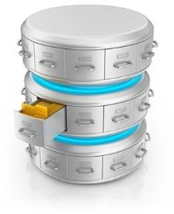  A | 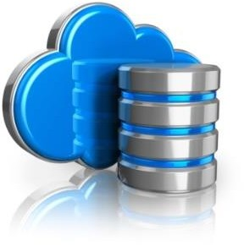  B
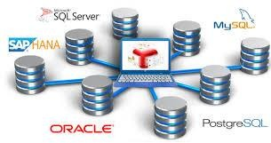  C |   D

Read the Article

Database Management Systems

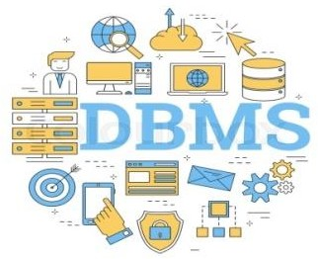
To the computer, a database looks like one or more files. In order for the data in the database to be read, changed, added, or removed, a software program must access it. Many software applications have this ability: iTunes can read its database to give you a listing of its songs (and play the songs); your mobile-phone software can interact with your list of contacts.
But what about applications to create or manage a database? What software can you use to create a database, change a database’s
structure, or simply do analysis? That is the purpose of a category of software applications called database management systems (DBMS).
A DBMS makes it possible for end users to create, read, update and delete data in a database. The DBMS essentially serves as an interface between the database and end users or application programs, ensuring that data is consistently organized and remains easily accessible. The DBMS manages three important things: the data, the database engine that allows data to be accessed, locked and modified - and the database schema, which defines the database’s logical structure. These three foundational elements help provide concurrency, security, data integrity and uniform administration procedures. Typical database administration tasks supported by the DBMS include change management, performance monitoring/tuning and backup and recovery. Many database management systems are also responsible for automated rollbacks, restarts and recovery as well as the logging and auditing of activity.
A key component of a DBMS is the database engine – the part of the program that actually stores and retrieves data. In addition to a database engine, most DBMSs come bundled with a set of tools to perform a variety of necessary tasks, such as creating forms (used to input data) and reports (used to output data), and interfacing with query languages and programming languages for complex applications. Programming languages typically used with databases today include Visual Basic, Java, and C++, although many older legacy database systems still use COBOL.
DBMS packages generally provide an interface to view and change the design of the database, create queries, and develop reports. Most of these packages are designed to work with a specific type of database, but generally are compatible with a wide range of databases.
For example, Apache OpenOffice.org Base can be used to create, modify, and analyze databases in open-database (ODB) format. Microsoft’s Access DBMS is used to work with databases in its own Microsoft Access Database format. Both Access and Base have the ability to read and write to other database formats as well.
Microsoft Access and Open Office Base are examples of personal database-management systems. These systems are primarily used to develop and analyze single-user databases. These databases are

not meant to be shared across a network or the Internet, but are instead installed on a particular device and work with a single user at a time.
DBMSs are designed for a variety of environments. Some are designed to be single-user systems, while others are designed for medium-sized businesses, while still others are designed for large businesses.

Advantages of a DBMS
Using a DBMS to store and manage data comes with advantages, but also overhead. One of the biggest advantages of using a DBMS is that it lets end users and application programmers access and use the same data while managing data integrity. Data is better protected and maintained when it can be shared using a DBMS instead of creating new iterations of the same data stored in new files for every new application. The DBMS provides a central store of data that can be accessed by multiple users in a controlled manner.
Central storage and management of data within the DBMS provides:
- Data abstraction and independence;
- Data security;
- A locking mechanism for concurrent access;
- An efficient handler to balance the needs of multiple applications using the same data;
- The ability to swiftly recover from crashes and errors, including restartability and recoverability;
- Robust data integrity capabilities;
- Logging and auditing of activity;
- Simple access using a standard application programming interface (API);
- Uniform administration procedures for data.
Another advantage of a DBMS is that it can be used to impose a logical, structured organization on the data. A DBMS delivers economy of scale for processing large amounts of data because it is optimized for such operations.
A DBMS can also provide many views of a single database schema. A view defines what data the user sees and how that user sees the data. The DBMS provides a level of abstraction between the conceptual schema that defines the logical structure of the database and the physical schema that describes the files, indexes and other physical mechanisms used by the database. When a DBMS is used, systems can be modified much more easily when business requirements change. New categories of data can be added to the database without disrupting the existing system and applications can be insulated from how data is structured and stored.
Of course, a DBMS must perform additional work to provide these advantages, thereby bringing with it the overhead. A DBMS will use more memory and CPU than a simple file storage system. And, of course, different types of DBMSes will require different types and levels of system resources.

Comprehension check.
- What parameters are considered while classifying a database system? Identify some basic database classifications and discuss their differences.
- What are the characteristics of cloud databases?

- How is a relational database designed, used, and maintained?

Use of Language Practice

Task 1. Match words (1-10) to their synonyms (a-j)

- concurrency  - backup  - rollback  - logging  - query language  - overhead  - iteration  - economy of scale | - a proportionate saving in costs gained by an increased level of production  - in computer science, it is generally considered any combination of excess or indirect computation time, memory, bandwidth, or other resources that are required to attain a particular goal  c repetition of a mathematical or computational procedure applied to the result of a previous application  d the procedure for making copies of data in case the original is lost or damaged  - the ability of a database to allow multiple users to affect multiple transactions.  - just a fancy word to define a process of writing down everything you do  - the process of restoring a database or program to a previously defined state, typically to recover from an error  - a language for the specification of procedures for the retrieval (and sometimes also modification) of information from a database

Task 2. Use the words from the table to complete the following sentences. Consider correct grammar use.

- In database technologies, a is an operation which returns the database to some previous state. They are important for database integrity, because they mean that the database can be restored to a clean copy even after erroneous operations are performed.
- All small island developing states lack the to overcome their vulnerabilities on their own.
- SXPath may be used as a for an XML-based digital library.
- enables refinement of the work product through encouraging brief returns to previous steps.
- Make a of any work you do on the computer.
- is keeping a record of all data input, processes, data output, and final results in a program
- The ability to offer is unique to databases.
- For example, maintaining an audit trail might result in 10% , meaning that the program will run 10% slower when the audit trail is turned on.

Task 3. For questions 1-13, read the text below and choose the most appropriate word from the list (A-Q) for each gap. There are THREE EXTRA WORDS that you do not need to use. There is an example at the beginning (0).

Skills Essential for a Database Developer or Programmer

To stay (L) COMPETITIVE, a student studying to be a database (1) … should strive to be (2) … in more than one programming language. In the not-too-distant past, it was sufficient for an (3) … database developer to be proficient in just database (4) … (i.e., SQL programming). However, to be competitive in today’s market, a database developer should be (5) … in database programming, as well as in (6) … programming such as JavaScript/HTML and a specific programming language such as C/C++. Aspiring database programmers today will have to work with databases that (7) … almost all types of applications, and almost all (8) … will use databases. Students should know how to (9) ... databases, write (10) … (i.e., SQL), and do maintenance. They should also know the
- … of normalization as this leads to fantastic database design. In fact, database skills are important for all (12) … students since most are going to (13) … some sort of database work in the real world, and they will want to be able to speak the language.

A computer | E proficient | I able | M run
B system | F design | J analysis | N encounter
C principles | G queries | K programming | O aspiring
D front-end | H developer | L competitive | P fluent
 |  |  | Q applications

Task 4. Read the information about enterprise databases. Change the sentences into the active or passive ones.

Enterprise Databases

  - If only a single user can use a database at a time it is not going to meet the needs of most organizations.
  - As they have networked computers and now join them worldwide via the Internet, a class of database has emerged that two, ten, or even a million people can access.
  - These databases are sometimes installed on a single computer to be accessed by a group of people at a single location.
  - Other times, they install them over several servers worldwide, which means millions are able to access them.
  - These relational enterprise database packages are built and supported by companies such as Oracle, Microsoft, and IBM. The open-source MySQL is also an enterprise database.
  - As stated earlier, the relational database model does not scale well.
  - The term scale here refers to a database getting larger and larger, distributed on a larger number of computers connected via a network.
  - Moving away from the relational model to other, more flexible models, some companies are looking to provide large-scale database solutions.
  - For example, Google now offers the App Engine Datastore based on NoSQL.
  - Developers can use the App Engine Datastore to develop applications that access data from anywhere worldwide.

Speaking Task

There are numerous databases that contain personal but public information about individuals. Today much of this data is available online.

- How do you feel about your personal information being contained in databases that other individuals can access or that might be breached via the Internet?
- Do you mind that anyone with an Internet connection could find out how much you paid for your house if you are married, where you live, and other personal information?

It is becoming increasingly common for biometric devices to be used to grant or deny access to facilities and identify consumers for financial transactions. In order to facilitate this, some data about each participant’s biometric features must be stored in a database.

- How do you feel about your biometric characteristics being stored in a database?
- Does it depend on whether the system belongs to your bank, employer, school, or the government?
- Because biometric features cannot be reset, are you at risk using a biometric ID system? Why or why not?

Writing Assignment

Project the topic “Roles and Advantages of DBMS in organizations”. Prepare an essay or make a presentation in class revealing the main issues of the topic with a couple of specific examples.

